**Web Designing Assignment**

**Term-1**

**Module (HTML)-1**

**1.Are the HTML tags and elements the same *thing?***

**Ans.TAGS- Tag are those which comes in between angularbrackets 90% tags are come with starting**

**and closing Tag.**

**Element = start tag - some content - end tag**

**2. what are tage and attributes in HTML.**

**Ans.TAGS- Tag are those which comes in between angularbrackets.**

**Attributes-They provide some Additional information which change the behaviour of Element.**

**Always come in start Tag**

**3.What are void elements in HTML? With Example**

**Ans.A void element is an element whose content model never allows it to have contents under any**

**circumstances.**

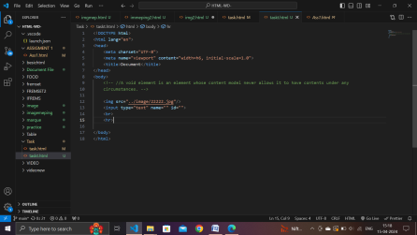

**Example:-br,hr,img,input, command, etc.**

**4.What are HTML Entities? With Example**

**Ans.HTML entity is used to display invisible characters and reserved characters that would**

**otherwise be interpreted as HTML code.**

**It is a piece of text, or string, that begins with an ampersand ( & ) and ends with a semicolon ( ; ).**

<p>This is a &lt;p&gt; tag.</p>

**5.What are different types of lists in HTML? With Example.**

**Ans.Three types of list**

**1.unorderlist**

**2.orderlist**

**3.Description list**

**unorderlist-used to group a set of related items in no particular**

**orderlist-used to group a set of related items in a specific order.**

**description list — used to display name/value pairs such as terms and definitions**

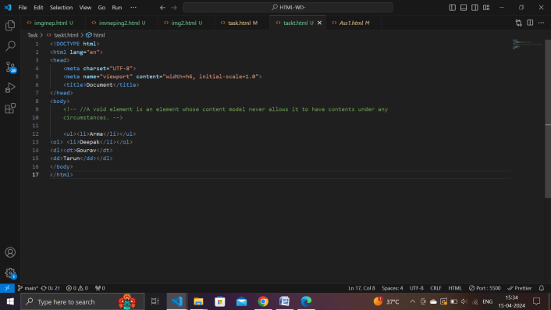

**6.What is the 'class' attribute in HTML? With Example**

**Ans.The class attribute specifies one or more classnames for an element. The class attribute is**

**mostly used to point to a class in a style sheet.**

**Exampal- <h1 class=”intro”>Header 1</h1>**

**7.What is the difference between the 'id' attribute and the 'class' attribute of HTML elements?**

**With Example.**

**ANS.A Class name can be used by multiple HTML elements, while an ID name must only be used by**

**one HTML element within the page.**

**Example- <h1 class=”intro” id=”header”>Header 1 </h1>**

**8.What are the various formatting tags in HTML?**

**Ans.Formatting elements were designed to display special types of text**

**- Bold text. - Important text.**

**- Italic text.**

**- Emphasized text.**

**- Marked text.**

**- Smaller text.**

**- Deleted text.**

**- Inserted text.**

**9.How is Cell Padding different from Cell Spacing? With Example.**

**Ans.Cellpadding basically defines the space present between a table cell's border and the content**

**present in it. Cellspacing basically defines the space present between individual adjacent cells.**

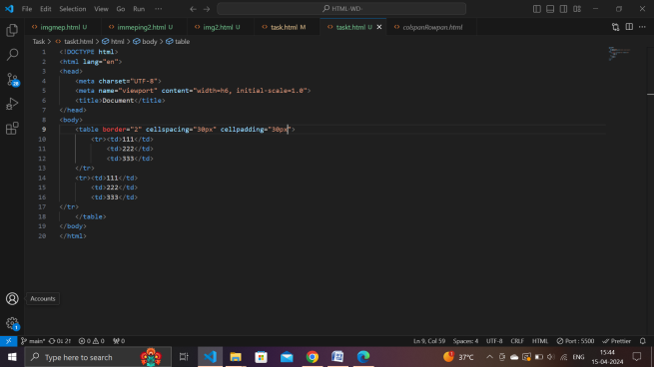 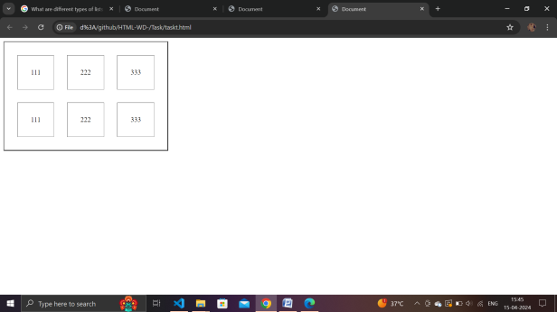

**10.How can we club two or more rows or columns into a single row or column in an HTML table?**

**With Example.**

**Ans.We use the colspan and rowspan attribute, to merge cells in HTML. The rowspan attribute is for**

**the number of rows a cell should merge, whereas the colspan attribute is for the number of**

**columns a cell should merge. The attribute should be placed inside the "" tag.**

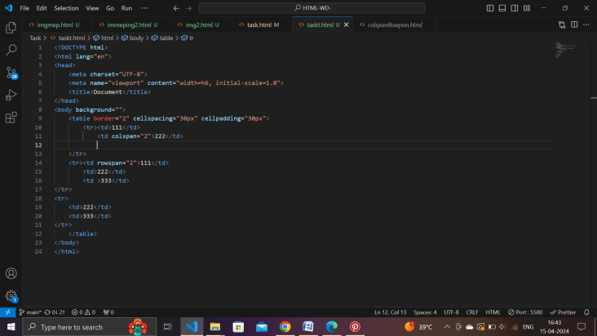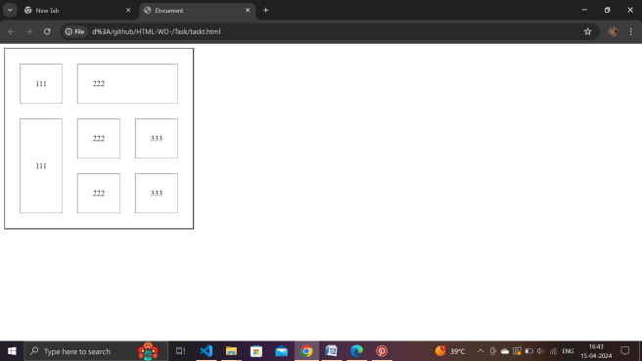

**11.What is the difference between a block-level element and an inline element?**

**Ans.Inline elements never start from a new line. Block elements cover space from left to right as far**

**as it can go. Inline elements only cover the space as bounded by the tags in the HTML element.**

**Block elements have top and bottom margins.**

**12.How to create a Hyperlink in HTML? With Example.**

**Ans.To make a hyperlink in an HTML page, use the 'a' and '/a' tags, which are the tags used to**

**define the links. The 'a' tag indicates where the hyperlink starts and the '/a' tag indicates where**

**it ends. Whatever text gets added inside these tags, will work as a hyperlink. Add the URL for**

**the link in the 'a href=” ”'.**

**Example - <a href=”https//www.google.com>visit google.com!</a>**

**13.What is the use of an iframe tag? With Example.**

**Ans.An inline frame (iframe) is a HTML element that loads another HTML page within the**

**document. It essentially puts another webpage within the parent page. They are commonly**

**used for advertisements, embedded videos, web analytics and interactive content.**

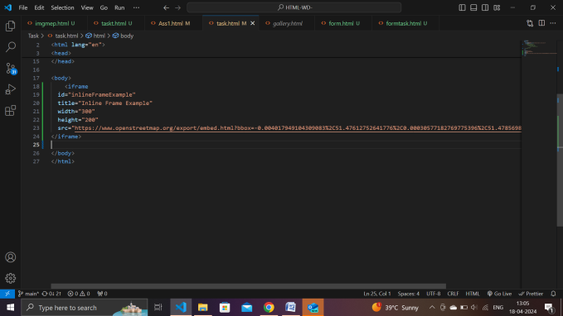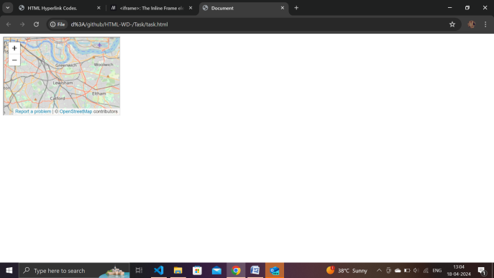

**14.What is the use of a span tag? Explain with example?**

**Ans.The span tag is a paired tag means it has both open(<) and closing (>) tags, and it is mandatory**

**to close the tag. The span tag is used for the grouping of inline elements & this tag does not**

**make any visual change by itself.**

 <p>My mother has <span style="color:blue">blue</span> eyes.</p>

**15.How to insert a picture into a background image of a web page? With Example.**

**Ans.Method 1: Using background attribute**

**1. Step 1 - First we will define the HTML code.**

**2. Step 2 - Now we will edit the body tag to use the local file image. jpg as the background image.**

**3. Step 1 - First we will define the HTML code.**

**4. Step 2 - Now we will add CSS.**

**16.How are active links different from normal links?**

**Ans.Those that don't have a mouse cursor over that link is considered a normal link. Some browser**

**recognize active links when the mouse cursor is placed over that link.**

**17.What are the different tags to separate sections of text?**

**Ans.We separate a section of texts in HTML using the below tags:**

**1. br tag - It is used to separate the line of text. It breaks the current line and shifts the flow of the**

**text to a new line.**

**2. p tag-This tag is used to write a paragraph of text.**

**3. blockquote tag-This tag is used to define large quoted sections.**

**18.What is SVG?**

**Ans.SVG stands for Scalable Vector Graphics. SVG is used to define graphics for the Web.**

**19.What is difference between HTML and XHTML?**

**Ans.HTML stands for Hypertext Markup Language, whereas XHTML stands for Extensible Hypertext**

**Markup Language. XHTML is basically an extension of HTML, which is stricter than HTML. Both**

**languages are used to create web and Android applications. HTML is SGML based, whereas**

**XHTML is an XML-based language**.

**20.What are logical and physical tags in HTML?**

**Ans.In HTML the formatting tags are divided into two categories:**

**1. Physical tag: These tags are used to provide the visual appearance to the text.**

**2. Logical tag: These tags are used to add some logical or semantic value to the text.**